INTERIOR SILVICULTURE SUB-COMMITTEE (ISSC)
DISCUSSION PAPER – MAX DENSITY
November, 2017

Soon after 2003 fires, high density natural regeneration was identified in approximately 10-25% of the area burned in specific wildfires primarily in the Okanagan and Kootenays. Significant effort has been undertaken to assess, treat sites and manage costs. Strip thinning with mulchers, herbicide and manual treatments to various densities have been undertaken. Research trials have been set up to fill in gaps in our understanding of stand development with various species, stand establishment and post treatment densities. Since efficacy decreases and costs typically increase the bigger the trees are to cut, much of this effort is well underway.

High density regeneration from the recent fires was not limited to industry appraisal blocks. Requests for FFT funding for juvenile spacing prompted a review of the maximum density issue (FFT Review of Juvenile Spacing Investments, January 17, 2017). This included a literature and research review and update of how repression is defined. FFT currently utilizes a stand-level decision key to evaluate what projects are funded (Repression Density Treatment Decision Key, April 2016).

Although once similar to planting costs, the cost of juvenile spacing has increased significantly to 2-10 times the cost of planting and is well above current appraisal allowance for reforestation. It is difficult to acknowledge the cost for spacing in the appraisal system since it is only required on wildfire salvage blocks and after year 5 which is the last time costs are captured for Appraisal manual updates.

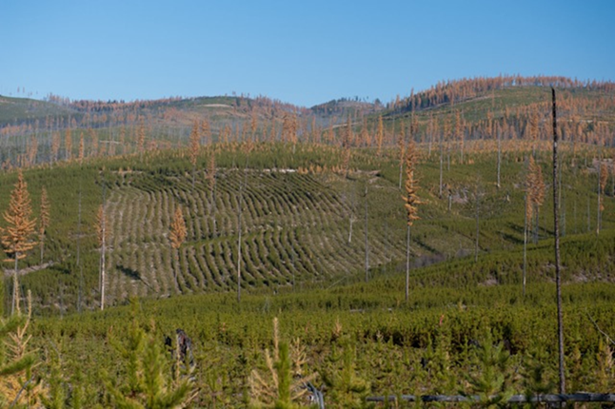

Image 1. Mulching, similar to hydro-axing completed in the 1980s and 90s, is one method utilized to reduce the significant cost of manual treatments. Evaluating if the mulching treatment was effective at reducing densities and competition to allow FG declaration or if further treatment is still required are questions currently under review in addition to the cost benefit and threshold densities.

Discussion about what is an appropriate maximum density number has been going on since 1987 when licensee responsibility for reforestation began. It was originally set at 5000 sph in 1990 and was moved upward to 10,000 sph in 1998 (based on achieving a certain piece size not just volume). In 2002, the 10,000 sph was effectively increased by introducing the concept of countable stems per hectare. In February 2006, the Southern Interior Forest Region (SIFR) increased the max density threshold to 25,000 countable stems per hectare. Similarly in July 2017, the NIFR increased the max density for that region to 20,000sph. Both recent decisions were the result of increased information, minimal impact on forest health and other resources and primarily due to small magnitude of issue as it impacted less than 2% of regenerating stands.

There are thousands of hectares of spaced stands including strip thinning that should help us understand impacts of treatments and densities. However, many of these sites and studies had no control, are now dead from disease or wildfire or were spaced to very low densities which makes direct comparison a challenge. In addition, information on the impacts on species other than lodgepole pine is very limited.

Interestingly, both SIFR and NIFR letters, in 2006 and 2007 respectively, discussed the importance of developing a monitoring program across a range of sites and densities to evaluate long-term impacts. Unfortunately, this continues to be an important need to further our understanding of the factors to consider when determining max density thresholds and to evaluate the cost benefit of the treatment cost with the expected result.

There are also thousands of hectares of problem forest types (PFT) of high density small piece size stands removed from the THLB that we do not want to contribute more hectares to. Unfortunately, it is not well understood what the establishment densities were and how that compares to initial densities of the hundreds of thousands of hectares of merchantable Pli that was also fire regenerated.

In addition, climate change, forest health, increasing scale/frequency of wildfires, wildlife habitat, creating commercial thinning opportunities and future fire risk may also need to be considered in this evaluation of maximum stand density.

Lack of consistency between FFT funding and licensee obligations, new information on repression and a 250-400% increase in spacing treatment costs prompts the review of the cost benefit of juvenile spacing.

Legal Requirement (summarized note from Kevin Astridge)

The term maximum density is used to describe a tree density threshold, above which the licensee responsible for an opening is obligated to conduct a juvenile spacing treatment prior to declaring a stand free growing. The term repression level, as used in early silviculture prescriptions, has the same meaning as our current definition of maximum density.

Forest Practices Code (FPC) era Opening:
Density levels must be controlled as per the densities prescribed in the approved SP or PHSP.
- For silviculture prescriptions or site plans approved before April 1, 1994, maximum density of lodgepole pine or drybelt Douglas-fir is 10 000 sph or number specified by the district manager.
- SP approved on or after April 1, 1994, and the number of conifers per hectare exceeds 10 000 or a number specified by the regional manager, prior to the free growing date, the number of conifers must be reduced to within the range specified in the silviculture plan or prescription.
- In 2002, the introduction of the countable conifer concept effectively increased the 10,000 maximum density spacing threshold.

Countable conifers
When determining if the total number of conifer trees (TC) exceeds maximum density, an understanding of countable conifers is required. For even aged silviculture systems: determine the median (middle) height of the largest well spaced trees to a maximum of the M value. Where the median height of the well spaced trees is;
<2m, the countable height is 30% of the median well spaced height
>2m, the countable height is 50% of the median well spaced height

- In Feb 2006, the Southern Interior Forest Region increased max density threshold to 25,000 countable conifers per hectare where lodgepole pine is >80 in the inventory label and 10,000 countable conifers per hectare all others.
- August 2007, the Northern Interior Forest Region, increased threshold to 20,000 countable conifers per hectare where lodgepole pine is >80 in the inventory label and 10,000 countable conifers per hectare all other species.

Forest and Range Practices Act (FRPA) era Opening
For those areas managed under an FSP or WLP, maximum density levels approved within the plan will apply. If an FSP or WLP does not have a stated maximum density, then there is no default maximum density that applies.

For areas harvested after January 31, 2004, under a FSP and areas where the FSP has specified that FRPA FSP stocking standards apply, the responsibility to conduct juvenile spacing treatments will depend on the contents of the plan itself. Stated maximum densities range from 10,000 to 30,000 countable conifers/ha.

FRPA definition of a "free growing stand" means a stand of healthy trees of a commercially valuable species, the growth of which is not impeded by competition from plants, shrubs or other trees.

FRPA requires licensees to maintain or enhance an economically valuable supply of commercial timber, consistent with Timber Supply analysis and forest management assumptions considering merchantable diameters, harvest volume, rotation length and harvest cost.

Discussion Points:

- In current FRPA legislation, maximum density is equal to repression density.

- Reference to post spacing treatment density is not specified in FRPA and could be removed from stocking standards.

- Does the current countable conifer definition reflect the threshold where natural mortality and stand differentiation occurs?

- Separate wildfire vs post harvest regeneration – importance here is understanding how long it takes to establish a stand and the effect this has on stand differentiation. This also impacts interpretation of some of the research like Barnes lake.
  - Barnes Lake – trees were sown in 1 day and planted in 2 days so establishment is completely at the same time.
  - Wildfire – trees are all the same age but established within a few weeks or months. This difference contributes to some stand differentiation.
  - Post harvest regeneration – logged and regen fills in over 1-10 years. There is large differentiation in the stand so repression is unlikely.

If max density rarely applies to any sites other than wildfires, is this very significant? Yes, it influences how research was interpreted. Provide example.

- Are adequate trials established to improve our understanding of stand density impacts on stand development? What trials are currently established and what is being monitored? Who is lead?

- What new information is available to better identify the threshold maximum density that trees are impeded. How does max density vary by:
  - Species – should max density only apply to Pli and Lw?
  - Site index - repression occurs at lower densities on drier sites so is one number appropriate way to minimize risk of repression to crown?
  - Forest health – are there sites with forest health concerns that higher natural mortality should be managed for.

- Should Silviculture investment on crown land be consistent between IA obligations and FFT?
  - If same fire and 2 areas are adjacent, is it defendable that the licensee has to pay $3500/ha to treat max density issue but FFT will not pay that on the adjacent site?

- Should FFT Juvenile Spacing Review document and Decision Key apply to Industry Appraisal obligations?
  - Does the lower volume potential of low SI sites reduce the amount that is practicable to spend / ha. Does it make sense to spend $4000/ha to space a site with SI 15?
  - Should we include ROI threshold for max investment on IA?
  - Are there gaps or updates in the document that need to be addressed before this was possible?

- Should maximum density spacing be considered basic Silviculture? If yes, does the current funding mechanism adequately recognize the cost or are changes needed.
  - The time to space and address repression is when stand is less than 1m tall so could lose opportunity if density control isn’t considered basic Silviculture
  - Appraisal only looks at treatments required for 5 years after harvest and often spacing is not identified by then.
  - Unpredictable nature of max density issues make forecasting difficult.
  - Could a specific appraisal allowance for wildfire salvage be applied if max density issue expected.
  - Could max density spacing could be considered FFT funded activity once you prove it is required, licensee administered similar to section 108.

- Standard Silviculture surveys often underestimate the density of the stand. Post wildfire densities are highly variable and difficult to stratify which may result in an underestimate of the max density issue. Investigate potential opportunity for surveys to use imagery and automated analysis of tree counts.
  - Paul - Greg Jorgenson to followup with Steve Jones (Monty)

Options:
- No change to max density thresholds.
- Increase max density thresholds.
- Implement stand level evaluation of max density using Repression Density Decision Key.
- Other:

Recommendations:
- Update Survey Manual to count stems using a very small plot and not estimate countable conifers.

- Update FFT Juvenille Spacing Review document and Decision Key:
  - Definition of site tree used to calculate max investment is critical and should be discussed – representative tree vs the largest.
  - Current planned updates to report include
      - a succinct survey methodology for implementing the techniques outlined in the Repression Density Treatment Decision Key report including when to survey using a 1.0m X 1.0m plot, or a 0.56m radius plot & methodology. (Rather than using the standard provincial survey methodology in the Silviculture Survey Procedures Manual.)
      - Correct Flow Chart changing “Top Height” to “Site Tree”. Create print off flow chart & to allow people to walk their way through it easier. Define how to pick the appropriate Site Tree. (Use existing published method.)
      - Print off appropriate break even table
      - Summarize SI data collected. (There is a need for some analysis to understand better.)
      - Define Site Index determination methodology. (Use existing published method.)
      - Refine Table 2 from The Report by replacing extrapolated data with empirical or modelled data.

Scope of the Issue

- Results data from 2015 is attached but it does not show planned activities and blocks not FG.

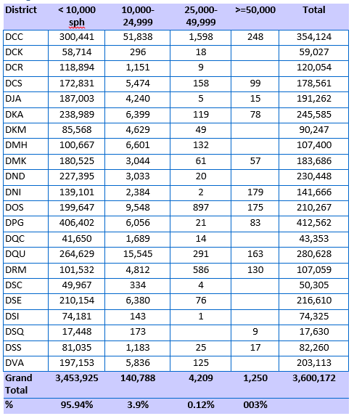

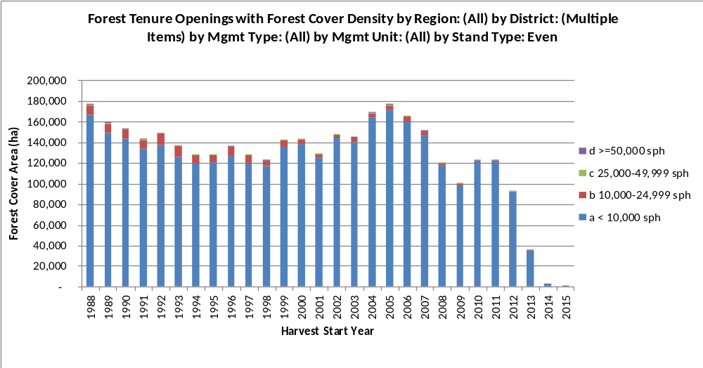

  - Licensee known issues:
    - Weyerhaeuser Okanagan – 821 ha NOT FG under IA funding:
      - Completed Activities (IA Funded on Fire Blocks)
        - JS Mulcher: 245 Ha
        - JS Chemical Ground: 198 Ha
        - JS Excavator: 17 Ha
        - JS Brush/Power Saw: 37.8 Ha
      - Planned Activities (IA Funded on Fire Blocks)
        - JS Manual Brush Saw: ~250 Ha currently above 30,000 cc stems/ha, that will need to be spaced to meet current rules.
  - Canfor Kootenays
    - 2700 ha fires, 1600ha NFG
    - 2038 ha spacing completed, 507 ha still planned (some areas mulched and manual so counted twice)
    - Spent over $2M, silv is roughly $14-20/m3

  - PG/Vanderhoof area – BCTS, Tolko, Canfor (50ha) and WF

  - BCTS:
    - Rocky Mountain District: On the lamb creek fire (total area = 11,000 ha??) we salvaged about 1200ha and needed to space about 300ha (25%). About 15% of that was larch leading.
    - Vernon, Kamloops, Kelowna – has sizeable amount of hectares requiring treatment but awaiting on actual amount

